**College Acceleration Programs in Michigan**

**DRAFT Report**

**Prepared for the Michigan Legislature in Response to HB 5396 (section 234)**

**Background**

The Michigan Legislature asked the Department of Education to provide a report that examines participation in and outcomes for five college acceleration programs (CAP) supported by the state of Michigan. These programs include International Baccalaureate (IB), Advanced Placement (AP), Dual Enrollment (DE), Early Middle College (EMC), and Career and Technical Education (CTE). The Michigan Department of Education collaborated with the Center for Educational Performance and Information and the Education Policy Initiative to conduct the analysis and produce this report.

**Data Sources and Methods**

This report draws on administrative data collected and maintained by the Michigan Department of Education and the Center for Educational Performance and Information. A roster of all high school students enrolled in Michigan public schools was drawn from the Michigan Student Data System (MSDS), which was matched to their participation in each of these five programs as indicated in the Teacher Student Data Link (TSDL) data collection. Postsecondary attendance, degree completion, and course-taking were taken from the Student Transcript and Academic Record Repository (STARR) and the National Student Clearinghouse (NSC). Our analysis is entirely descriptive. When examining participation and outcome differences across programs, it is important to note that these can be caused by several factors outside our analysis.

**Key Findings**

* Student participation in four of the five CAP programs has grown since 2015-16, with some experiencing significant growth. Student participation in EMCs has increased by 73%, DE participation has grown by 35%, AP participation has increased by 11%, and CTE participation has increased by 3% though the CTE completer rate has grown by 74% during the same time period.
* Approximately 50% of students in grades 9 - 12 participated in at least one of the college acceleration programs. Since 2015-16, four out of the five CAP programs experienced growth in terms of the number (and share) of high school students participating.
* Underrepresented groups have lower participation rates in these programs, though these groups have demonstrated measurable participation gains in a number of Michigan’s CAP programs since 2015-16.
* Participants in Dual Enrollment and Early Middle College earn a significant number of college credits - 10 to 15. Fewer AP participants earn credits towards a college degree, either because they don’t take the AP exam or do not score high enough.
* Participation is highest for CTE and all state-approved secondary CTE programs are required to have a postsecondary linkage, but this linkage may be via dual or concurrent enrollment or via articulated credit, which is not tracked. Thus few high school CTE participants earn postsecondary credit that is tracked through their CTE program.
* Students participating in CAP programs have higher rates of college enrollment and degree completion than students not participating. Postsecondary attainment rates of AP, IB, DE, EMC, and CTE participants within four years of high school are 44%, 45%, 47%, 65%, and 29%, respectively. These rates compare favorably to the 32% rate for all Michigan high school graduates.
* Participation in the most intensive program - Early Middle College - is associated with very high rates of taking advanced college coursework in the first year and high rates of rapid degree completion.

*This report contains analysis conducted by William Metz and Yincheng Ye from the Michigan Department of Education (MDE), Brandon Baryo, Matthew Drake, Jason Larsen, and Holly Wilson from the Center for Educational Performance and Information (CEPI), Sabrina Solanki, and Jonathan Hartman from the Education Policy Initiative (EPI) at the University of Michigan. This project was collaboratively directed and overseen by Scott Koenigsknecht and William Pearson at MDE, Michael McGroarty and Heather Handley at CEPI, and Kevin Stange at UM’s EPI. Important contributions were made by Jill Kroll and Victor Bugni from MDE, as well. This report was written by Nicole Wagner Lam and Kevin Stange from the University of Michigan’s EPI, with substantial input from the rest of the project team.*

## Participation trends over time

In 2019-20, approximately 50% of students in grades 9 - 12 participated in at least one of the college acceleration programs (CAP) supported by the state of Michigan: International Baccalaureate (IB), Advanced Placement (AP), Dual Enrollment (DE), Early Middle College (EMC), and Career and Technical Education (CTE). While many students are more likely to participate in these programs later on in their high school trajectories (i.e. 11th or 12th grade), each of these programs is unique and offers students distinct opportunities to prepare for and progress through postsecondary education. This report illuminates successes over the past 4 years, as well as areas for growth.

Since 2015-16, four out of the five CAP programs experienced growth in terms of the number (and share) of high school students participating. In Figure 1 below, you can see that Advanced Placement and Dual Enrollment programs increased the number of students participating by about 7,500 each. For AP, this represents an 11% increase over total enrollment in 2015-16. For DE, this is a 35% improvement over participation 5 years ago. Even more impressive, we find that Early Middle College participation almost doubled in that time. Career and Technical Education experienced smaller, yet still visible gains in participation between 2015-16 and 2019-20.[1] The International Baccalaureate program, however, experienced a 25% decline in enrollment with almost 4,000 fewer students in 2019-20.

**Figure 1. Change in College Acceleration Program (CAP) participation over time**

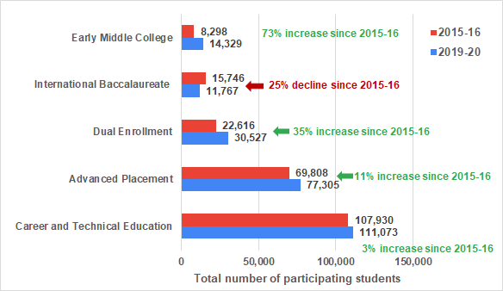

* Note: CAP programs are ordered by size from smallest to largest in the figure above.

In Michigan, CAP program participation tends to vary by student group. In fact, some student subgroups have been historically (and consistently) underrepresented in CAP programs: Black/African-American students, Hispanic/Latinx students, economically disadvantaged students, English Learners, and students with disabilities. By underrepresented, we mean that the share of grades 9 - 12 students in that group participating in the CAP program is lower than the proportion of **all** students who participate in the program. For example, the proportion of **all** grades 9 - 12 students who participated in AP was 14% in 2015-16, but the share of economically disadvantaged students who participated in AP in 2015-16 was only 6%. Therefore, economically disadvantaged students were underrepresented in AP programs in that year. Below, we show in Figures 2 and 3 the share of students from each subgroup who participated in CAP in 2015-16, by program, and how that compares to the proportion of all high school students who participated in that program.

**Figure 2. CAP program participation rates by student race / ethnicity grouping in 2015-16**

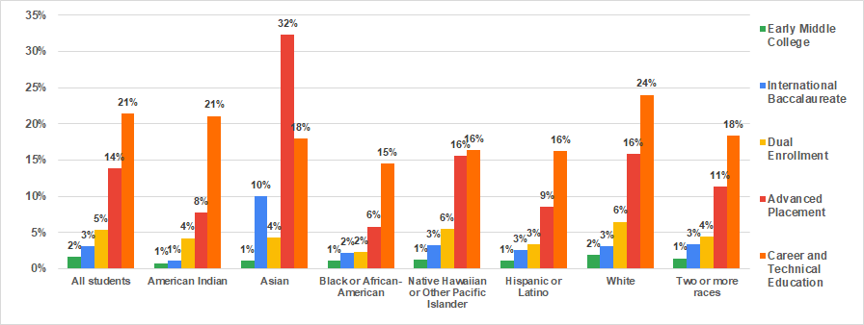

**Figure 3. CAP program participation rates by student subgroup in 2015-16**

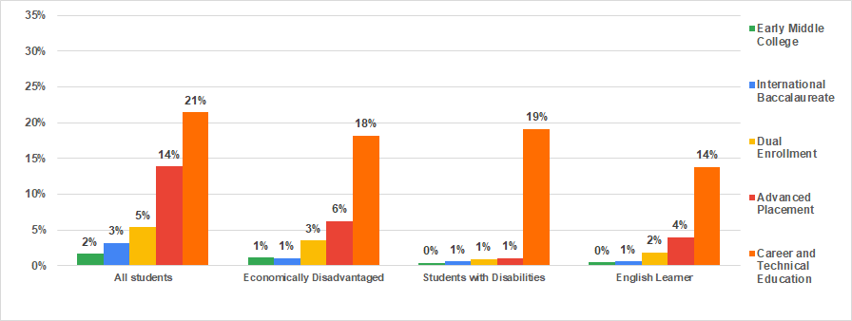

Encouragingly, underrepresented groups have demonstrated measurable participation gains in a number of Michigan’s CAP programs since 2015-16.

For example, the gains that Black/African American students (1.7 percentage points), Hispanic/Latinx students (2.8 percentage points), economically disadvantaged students (1.7 percentage points), and English Learners (1.9 percentage points) have made in **AP program participation** have virtually kept pace or been greater than the overall participation gains (2.2 percentage points) made by the program in 4 years.

**Figure 4. Percent of underrepresented students enrolled in AP in 2015-16 & 2019-20**

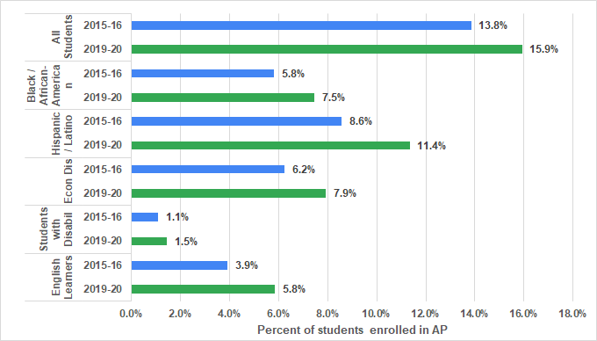

Similarly, Hispanic / Latinx students (who showed a 1.9 percentage point improvement), economically disadvantaged (2.8 percentage point improvement), and English Learners (3.3 percentage point jump) made greater gains in **DE program** participationover time--than all other students (1.8 percentage point gain), showing that a diverse group of students are increasingly taking advantage of the opportunity to obtain college credit while in high school.

**Figure 5.** **Percent of underrepresented students enrolled in DE in 2015-16 & 2019-20**

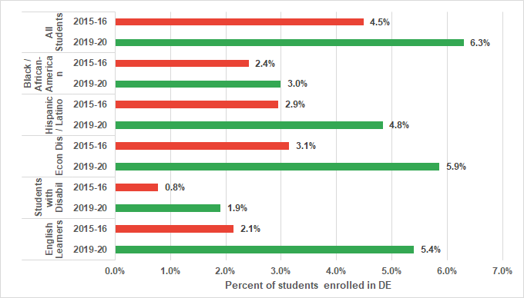

Though still a relatively small program, **Early Middle College** has demonstrated participation gains for every underrepresented student group, withHispanic / Latinx studentsandeconomically disadvantaged students experiencing the greatest gains (both showing 1.2 percentage point gains) over 5 years.

**Figure 6. Percent of underrepresented students enrolled in EMC in 2015-16 & 2019-20**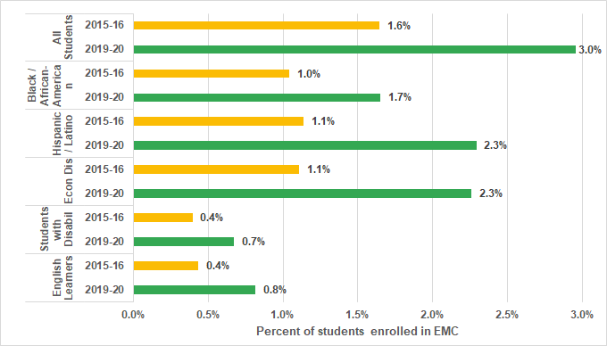

The largest CAP program, **Career and Technical Education**, has also demonstrated improvements in access for all underrepresented groups. The gains for English Learners (with a 4 percentage point jump) and Hispanic / Latinx students (2.3 percentage point gain), however, stand out as the gains for these students are substantially greater than the program’s participation gains overall (1.5 percentage point improvement).

**Figure 7. Percent of underrepresented students in CTE in 2015-16 & 2019-20**

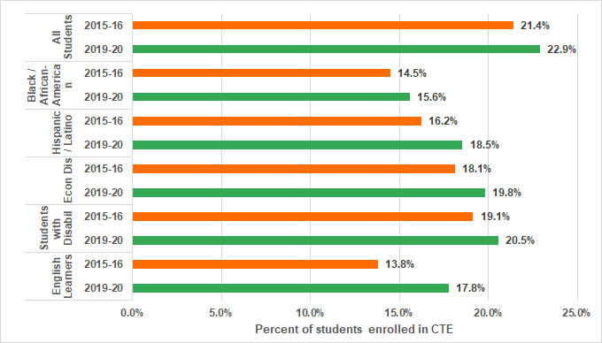

## Program Specific Student Progress Metrics

As previously mentioned, each college acceleration program has a target audience and distinct set of programmatic offerings, all of which bear out in student participation and course progress data.

### Advanced Placement

Advanced Placement courses are high school courses with entry-level college curricula approved by the [College Board](https://www.collegeboard.org/). AP courses are considered advanced courses that are meant to help prepare students for college and potentially help them to earn college level credits while in high school. After taking an AP course, some high school students choose to take what is called the AP exam that corresponds to the course subject area. AP exams are administered by the College Board, are graded on a one-to-five-point scale, and have a cost associated with them. The score that a student gets on the AP exam determines whether the AP course they have taken in high school will translate to college level credit when the student ultimately enrolls in postsecondary education. However, individual colleges and universities may have different criteria for whether to award college credit for passing scores on the AP test. Michigan State University, for example, awards eight credits for a score of four or five on the AP Chemistry test and five credits for a score of three.[2] Western Michigan University grants eight credits for an AP test score of five only, with four credits being granted for test scores of three or four.[3] Generally, college credits (corresponding to performance on an AP exam) are granted at the time of enrollment in a specific college or university. Student participation in AP programs has increased by 11% since 2015-2016.

A few other important notes about AP courses, AP exams, and how data are reported include:

1. Students who take AP courses are not required to sit for the corresponding AP exam. Therefore, the number of AP courses taken in Michigan in a given year will not necessarily correspond to the number of AP exams taken.
2. Students may also choose to sit for an AP exam even if they have not taken the corresponding AP course. In this report, the focus is on the impact of AP course taking. Therefore, AP tests taken by students who do not have at least one reported AP course in a given year were excluded from this report.
3. Because of the various ways that high school courses are named, it is not always possible to determine whether an AP course corresponds to an AP exam taken. Therefore, this report does not break the data down by AP course or AP exam subject.

It is also important to note that college credits earned as a result of participating in AP programs are not a required field for school districts when reporting information through the TSDL[4] data collection. Therefore, college credits earned as a result of AP are rarely reported. Finally, the state of Michigan does not collect college credits earned as a result of participation in the AP program in the STARR[5] collection. Because of these data limitations, we therefore focus on the number and share of students earning a three on the AP exam as a marker for the potential number of college credits received by AP students.

In Figure 8 below, a few different metrics of AP program participation and performance are presented together for a number of student groups in the 2018-19 school year. The reason that the data presented here is lagged by over a year is that AP exam taking was significantly interrupted by the pandemic in the 2019-20 school year. The 2018-19 school year is, therefore, the last year in which we have accurate data for each of the metrics presented below.

As you can see, the blue line tells us the average number of AP courses that students in each group took in 2018-19. It is important to keep in mind that this one-year snapshot does not tell us the cumulative story of the total number of AP courses taken by a student over their entire high school trajectory. However, the blue line gives us a sense for the fact that, on average, most AP students enroll in between 1 and 2 AP courses in a given year. The yellow and orange bars tell us about AP exam taking rates in 2018-19. In yellow, we see that 69% of all students who took an AP course in 2018-19 also took an AP exam. Moreover, 65% of those students who took an AP exam earned a score of 3 or above on that exam.

One important note to remind the reader of, however, is that there is no way currently to draw a straight line between the AP course that a student takes in a Michigan high school and the AP exam they take with the College Board. The reason for this is that local districts and schools in Michigan have a certain amount of autonomy in terms of the way that they name and code high school courses, which includes AP courses. These do not always allow for easy grouping or for perfect alignment to AP exams. As referenced earlier, students also are free to sign up for and take AP exams even if they have not taken the associated AP course. Therefore, there is not always perfect overlap between AP courses and AP exam taking.

**Figure 8. AP course loads, AP exam participation, and AP exam performance in 2018-19**

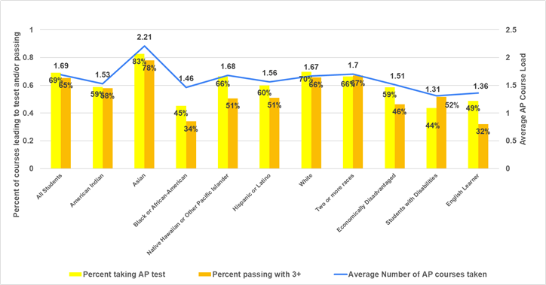

As is evident, there is variation between student groups in AP course and exam taking. American Indian AP course takers, Black / African-American, Hispanic / Latinx, economically disadvantaged, students with disabilities, and English Learner AP course takers are more likely to take just a single AP course in a year versus taking multiple. Additionally, each of these groups lag behind the all student average in terms of AP exam taking and pass rates. These factors in combination mean that (as compared to other students taking AP) students in these groups have less potential to earn college credit through AP and, therefore, are less likely to enter college at advanced standing as a result of AP. Nevertheless, it is heartening to see that rates of AP participation have increased among students in these groups (see figures in section above).

### International Baccalaureate

The International Baccalaureate (IB) program is a two-year program for students in 11th and 12th grades that provides an internationally accepted diploma recognized by thousands of colleges and universities throughout the world. At the end of the IB program, students will complete assessments in IB core components and six subject courses. Assessments award points ranging one through seven. Twenty-four points are required for successful completion of the IB program.

Individual colleges or universities may award college credit for certain scores on subject level IB assessments. The University of Michigan, for example, awards four credit hours for a higher-level (IB) Biology course with an assessment score of four[6], while Central Michigan University awards six credit hours.[7] Similar to AP, credits for IB program performance are granted upon enrollment in a specific college or university.

Finally, it is important to note that college credits earned as a result of participating in IB programs are not a required field for school districts when reporting information through the TSDL data collection. Therefore, college credits as a result of IB are rarely reported. The state of Michigan also does not collect college credits earned as a result of participation in the IB program in the STARR collection. Moreover, the [International Baccalaureate](https://www.ibo.org/) organization does not provide assessment scores to the State of Michigan. Therefore, we are not able to report college credits earned through participation in the IB program.

In Figure 9 below, however, two metrics of IB program participation and performance are shown for the 2019-20 school year, which is the most recent year of complete data. The number of courses that most IB students take in a given academic year is between 5 and 6 courses. Additionally, the percent of IB courses passed is quite high across all students (98%). But, we do see some variation among subgroups of students. American Indian students, students with disabilities, and English Learners, for example, appear to have the lowest course pass rates (95%) among the subgroups. The course pass rates for these groups, however, still remain quite high.

**Figure 9. Average IB course loads and course pass rates in 2019-20**

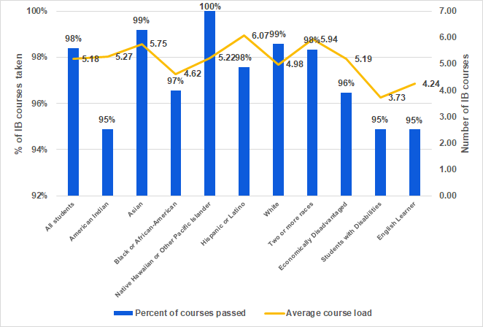

### Dual Enrollment

In Dual or Concurrent Enrollment (DE) courses, students take college classes while still enrolled in high school. Generally, these courses are taught by a postsecondary instructor at an institution of higher education, such as a community college or university. However, there are some cases where dual enrollment courses are offered and taken by students on high school campuses. Students have the option to take dual enrollment courses to receive a) credit toward both high school and college degree requirements, b) credit for high school only, c) credit for college only, or d) no credit at all (i.e., audit). Student participation in DE programs has increased by 35% since 2015-2016.

Students may take up to ten academic courses and apply these toward postsecondary degree requirements at a given eligible Michigan postsecondary institution. In contrast to AP and IB for which college credit is granted upon postsecondary enrollment, Michigan colleges and universities generally grant credits for dual enrollment courses upon successful completion of the college course. These limits do not apply when a written agreement exists between a public school district and a postsecondary institution, or if the district has elected to support a student’s enrollment beyond what is required in PA 160 of 1996.

Districts are required to report all courses for DE students for students in grades 9-12 in the TSDL collection. Additionally, college credits attempted is a required field for DE students. If the course is reported as “Completed – Passed”, either the college credits or local (high school) credits must be greater than zero. Therefore, in this report *college credits earned* is the total of credits attempted for completed-passed courses in TSDL.

In Figure 10, information regarding average DE course loads and number of college credits earned (while in high school) are shown. The red bars represent the average number of DE courses that participating students of various subgroups enrolled in for 2019-20. The blue line represents the average number of college credits that students taking DE courses earned. Given these two metrics, we can see that participating students typically take between 3 and 4 DE courses over the course of the year and that each successfully passed course translates to 3 college credits. Because students, on average, pass about 95% of their DE courses, the typical number of credits earned toward college by DE students in 2019-20 was approximately 10.

Also in Figure 10, we see variations across some student groups. For example, in the case of economically disadvantaged students, students with disabilities, and English Learners we find that participating students are more likely to average about 2 DE courses in 2019-20. Therefore, these students earn fewer credits toward college from DE courses (9.37, 7.34, and 7.59 credits respectively).

**Figure 10. Average DE course loads and credits earned toward college in 2019-20**

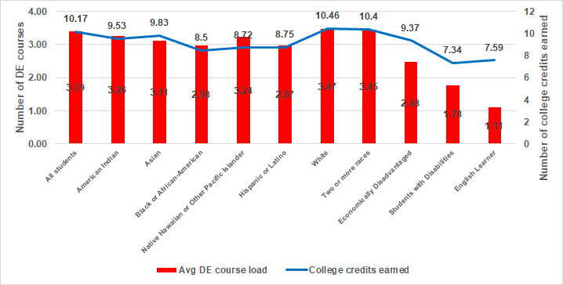

### **Early Middle College**

Early middle college (EMC) is a five-year high school program, starting in grade 9, designed to allow students to earn a high school diploma and one of the following: i) 60 transferable college credits, ii) an associate degree, iii) a professional certification[8], iv) the Michigan Early Middle College Association (MEMCA) technical certificate[9], or v) participation in a registered apprenticeship.[10] Michigan recognizes three types of Early Middle College programs:

1. **EMC High Schools:** a stand-alone public high school, where 100% of the pupils are enrolled as EMC students,[11]
2. **EMC Programs:** a high school designed such that less than 100% of the high school population is enrolled as EMC students,[12] and
3. **EMC Consortium:** An early middle college consortium program is comprised of multiple school districts with one coordinating agency.[13]

Student participation in EMC programs has increased 73% since 2015-2016.

EMC students must complete a five-year program of study that includes both high school and college level courses. EMCs must have established agreements with postsecondary partners[14] for the college level coursework. Partner colleges and universities grant credits upon successful completion of the college-enrolled courses.

Students may enroll in EMC programs as early as the 9th grade, students might be in an EMC program but not yet in any dual enrollment courses. However, since EMC courses that grant college credit are reported as DE in TSDL, we assumed for this report that all DE courses reported for EMC students are part of the EMC program. There is, therefore, no way to differentiate if a student is also taking DE courses unrelated to their EMC program. Again, college credits attempted is a required field for DE (and therefore EMC) students in TSDL. If the course is reported as “Completed – Passed”, either the college credits or local (high school) credits must be greater than zero.

In Figure 11, information regarding average EMC course loads and number of college credits earned (while in high school) are shown. The yellow bars represent the average number of EMC courses that participating students of various subgroups enrolled in for 2019-20. The blue line represents the average number of college credits earned in a given year by students taking EMC courses. Participating EMC students typically have a course load of about 4 courses each. The typical number of credits earned toward college by EMC students in 2019-20 was approximately 15. These college credits are most likely being earned by students in grades 11 - 13.

**Figure 11. Average EMC course loads and credits earned toward college in 2019-20**

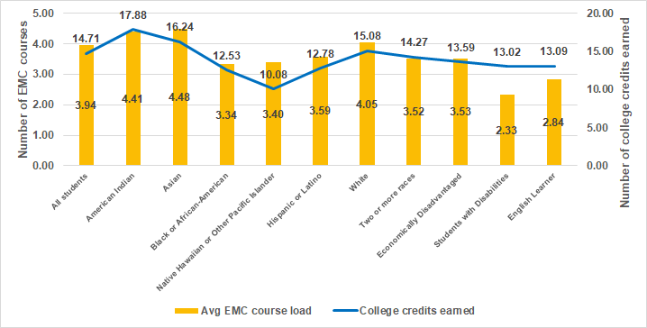

EMC also suffers from differential outcomes that some student groups have in the program relative to other students. For example, students with disabilities and English Learners average about 2 - 3 EMC courses in 2019-20, a much lower course load than all EMC students. While Black / African-American and Hispanic / Latinx students still took between 3 and 4 EMC courses in 2019-20, the average number of credits they earned toward college was considerably lower than was averaged by all other students (12.53 and 12.78 credits respectively).

### Career and Technical Education

Career and Technical Education (CTE) enrollees are students who attend a state approved CTE program[15], which is a sequence of courses that integrates required academic and technical skills, laboratory hands-on learning, work based learning, and student leadership opportunities leading to advanced education and/or industry-recognized credentials.[16] CTE programs fall into one of seventeen career clusters.[17] All state-approved secondary CTE programs in Michigan are required to have a postsecondary linkage but this linkage may be via dual or concurrent enrollment or via articulated credit. Student participation in CTE programs has increased 3% since 2015-2016 though the CTE completer rate has increased by 74% during the same time period.

There are various levels of intensity with which students participate in this program. A CTE “participant” completed less than half of the required state CTE program standards during high school. CTE “concentrators” completed over fifty percent of the required state CTE program standards, and CTE “completers” completed all CTE content standards plus took a technical skill assessment, if available, prior to high school graduation.[18]

CTE students taking dual enrollment courses earn college credits and these are captured in the Career and Technical Education Information System (CTEIS) at the time the student enrolls in a CTE course. As for college credits reported directly through the TSDL collection, in this report college credits earned in a CTE course reported in CTEIS is the total of credits attempted for completed-passed courses. Since articulated credits are not captured in CTEIS and vary by postsecondary institution enrolled in, our estimates may undercount the number of postsecondary credits students ultimately earn via CTE.

Figure 12 shows that CTE courses have a high pass rate - approximately 96% - though there are differences across student subgroup, with pass rates ranging from 93% to 98%. Despite this high pass rate, few college credits are earned by CTE students while in high school. The average CTE student earns 0.30 college credits in a year through their CTE courses, though this excludes any credits that will ultimately be obtained via articulation. In addition, there do appear to be differences in the average number of college credits earned by, for example, Asian CTE students (0.14 credits), Black/African-American students (0.11 credits), students with disabilities (0.19 credits), and English Learners (0.12 credits) as compared to all students (0.3 credits). The CTE program focuses on preparing students for the labor market rather than college credit accumulation; most CTE courses are simply not taken for college credit.

**Figure 12. Average CTE course pass rate and credits earned toward college in 2019-20**

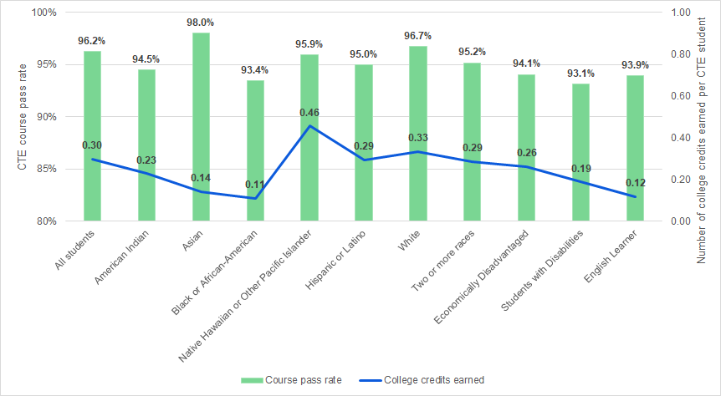

## Postsecondary Outcomes

In order to gain a better understanding of the extent to which CAP programs pave the way to and through postsecondary education for Michigan high school graduates, we examine the graduating class of 2015. By the close of the 2018-19 school year, these students have had the chance to complete four full years of postsecondary education and potentially earned a bachelor's degree (assuming that they entered college in the fall after high school graduation).[19] We know, however, that not every high school graduate follows this linear path to and through postsecondary education. So, we have followed all CAP participants from the 2015 graduating class and took note of postsecondary enrollment within one year of high school graduation, as well as within 3 years of high school graduation. We also looked at the extent to which students appear to have taken *advanced courses[20]* in their first year in college. Finally, we looked at whether CAP participants earned either an AA or BA degree within 4 years of high school graduation.

When looking at postsecondary outcomes it is important to note that any outcome differences across programs should not be equated with the *causal effect* of the program. For instance, the higher postsecondary enrollment and completion rates of CAP participants relative to all students reflects both the contribution of these programs but also all other factors such as academic preparation, financial resources, and collegiate goals that may differ between participants and non-participants.

Figure 13 below shows that the postsecondary enrollment rates (within 1 year and 3 years) of all Michigan high school graduates from the class of 2015 were 71% and 76% respectively. Students who participated in AP programs at any time in their high school trajectory enrolled in postsecondary at considerably higher rates, as did IB, DE, and EMC participants. Students who participated in CTE programs during high school enrolled in postsecondary at slightly lower rates than did all high school graduates.

**Figure 13: College enrollment rates, by CAP program**

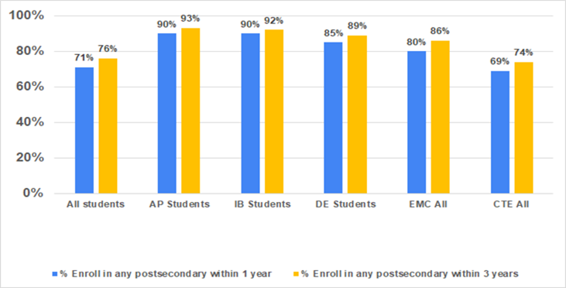

Also, notable is the fact that college enrollment outcomes differ for EMC students based on the intensity in which the students participate in this CAP program. For example, in Figure 14, we see that students who we consider EMC completers actually enroll in postsecondary at even higher rates (85% enroll within 1 year and 90% enroll within 3 years) than students who do EMC, but do not go on to do one of the following: a) earn an associate’s degree, b) earn 60 transferable college credits, c) earn a professional certification, d) earn a Michigan Early Middle College Association (MEMCA) Certificate, or e) participate in a registered apprenticeship.

**Figure 14: College enrollment rates, by Early Middle College intensity**

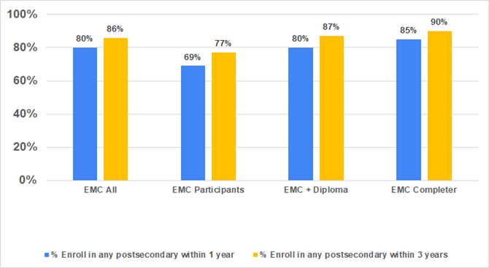

Similarly for CTE participants, we find that students who participated with more intensity had better college enrollment rates on average. While the college enrollment rates for students who participated in CTE to a lesser extent in high school (i.e. CTE participant) may have been lower than the average across all students, we find that CTE concentrators and CTE completers[21] had better college enrollment rates (on par or above the average across all students shown in Figure 12).

**Figure 15. College enrollment rates, by CTE program intensity**

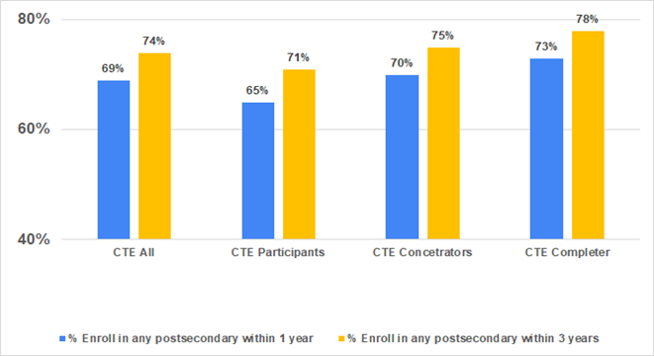

Once students enroll in college, the next hurdle they face is their first-year courses. Past research has shown that many students find their first year in college challenging for a whole host of reasons, some of which are related to the specific courses they take and the expense/debt incurred while enrolled in these courses. If first year courses repeat high school level content or material (i.e. are remedial in nature), students may find this unmotivating and choose not to continue on in subsequent years. Additionally, if the courses they are enrolled in during their first year are unrelated to the degree they hope to earn, this too may be unmotivating and a greater expense than students are able/willing to take on.

With this in mind, the hope is that CAP programs allow students to enter college and take more advanced courses in their first year so as to accelerate their path to a degree. When examining course-taking outcomes, we focus on students who attended a Michigan public college within 12 months of high school graduation. The reason being that the state of Michigan collects college course taking data from all Michigan public colleges and universities, as well as a range of other participating institutions of higher education within the state, but does not have this type of information for students who attend college outside of Michigan.

In Figure 16 below, we see that 28% of the courses taken by all students (including those who did not participate in CAP programs) in their first year of college could reasonably be considered *advanced*, meaning that the majority of their classmates were either sophomores, juniors, or seniors in college. When we compare that with the first-year courses of CAP participants, we find that all programs sent students into a higher proportion of advanced courses with the exception of CTE (whose students were on par with the average across all students). The programs that really stand out, though, are EMC and DE whose students, on average, took 61% and 38% advanced courses in their first year (respectively). In fact, over two-thirds of the courses taken in the first year of an EMC student who earned a diploma or an EMC completer could reasonably be considered an advanced college course.

**Figure 16. Share of courses taken by 1st year college students that are advanced**

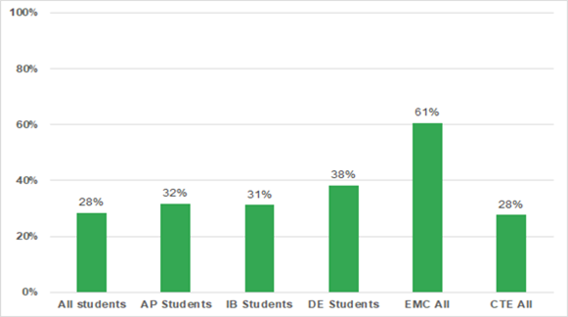

Finally, we examine the extent to which graduates from the class of 2015 went on to earn an AA or BA within 4 years of high school graduation. What we find is that 32% of all students who graduated from high school in Michigan in 2015 and also enrolled in a Michigan postsecondary institution within 12 months, earned an AA or BA within 4 years. Whereas, the postsecondary attainment rates of AP, IB, DE, and EMC participants were considerably higher (44%, 45%, 47%, 65%, and 29% respectively). Interestingly, AP and IB program participants lean toward BA degrees relative to AA degrees. DE and EMC students, however, lean more toward AA degrees within 4 years. Students from these programs still earn BA degrees at a considerably higher rate than the average across all students, though. Degree attainment rates for CTE participants are a bit lower than the state average, but these students are also graduating with postsecondary diplomas within 4 years.

**Figure 17. Postsecondary degree attainment within 4 years of high school graduation**

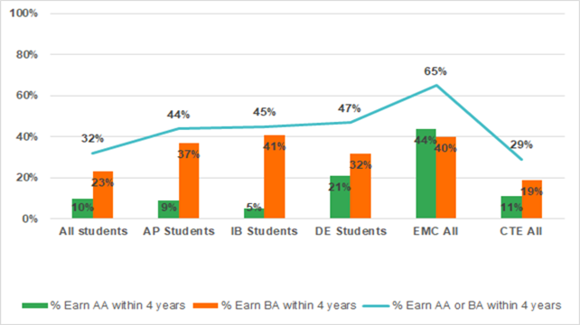

## Conclusion

Many high school students in Michigan participate in courses and programs that have potential to earn college credit, easing the transition into postsecondary schooling and potentially accelerating progress towards a degree. Such programs are quite varied in their structure, intensity, content, and breadth of participation but share a common goal of preparing students for life after high school. The state has witnessed a marked increase in participation in four of these programs over the past several years, particularly in Dual Enrollment and Early Middle College programs, whose participants have the highest rates of credit accumulation during high school and degree attainment within four years. These programs give students a jumpstart in college by allowing them to take more advanced coursework when they enter college and earn degrees more quickly. Students that complete the EMC program have exceptionally high attainment rates.

Our analysis necessarily omits many important outcomes. For instance, CTE differs from other CAP programs in that it includes many students enrolled in courses for high school, rather than college, credit. The CTE program has aims that are much broader than preparing students for postsecondary education, namely ensuring career readiness for students that are going to transition directly into the workforce. Our analysis does not capture these outcomes, but a more comprehensive analysis of these programs should. Another important set of outcomes involves college affordability and student debt. College acceleration programs lower the cost to students of earning postsecondary credits and credentials. This increase in affordability may reduce debt burden, improving students’ financial circumstances after college.

1. The CTE program completion rate also increased from 32.9% in 2015-16 to 45.4% in 2019-20, though this rate is difficult to interpret because the definition of CTE completer also changed during this time period.
2. https://admissions.msu.edu/documents/MSU_AP_Equivalencies.pdf
3. https://wmich.edu/registrar/students/advising/students-advising-ap
4. Teacher Student Data Link (TSDL) data collection.
5. Student Transcript and Academic Record Repository (STARR) data collection
6. https://admissions.umich.edu/apply/first-year-applicants/ap-ib-credit/ib-guidelines
7. https://www.cmich.edu/admissions/undergrad/incoming/Documents/IB.pdf
8. A professional certification is a certificate or industry-recognized credential for which a pupil prepares by taking coursework provided by a Michigan public or private college or university.
9. The MEMCA Certificate is conferred to the student by their home school district, if the student attends an EMC that has presented their college and career readiness curriculum to the MEMCA Leadership Council and has been approved to award the certificate. The EMC and local school district provide verification among the MDE, the school district, and the higher education partner that the graduate has successfully completed each of the following: a) the State of Michigan high school graduation requirements, b) a member school’s MEMCA approved College Readiness Curriculum, and c) a minimum of 15 transferable college credit hours (non-remedial courses). Additionally, one of the following options must be completed by the student; i) 100 hours of verified community service, ii) a minimum of 40 hours of verified career exploration, internship, job shadowing, or clinical experience, or iii) a combination of the two that equals 70+ hours
10. **MDE - Early Middle College High School Opportunities (michigan.gov)**
11. Examples of EMC High Schools are: Genesee Early College, Henry Ford Early College, Mott Middle College High School, Monroe County Middle College, Oakland Early College
12. Examples of EMC Programs are: Birch Run Early College, Carman/Ainsworth STEM Early College, Gull Lake Early College, Romulus Early College Program, Wyoming Public Schools
13. Examples of EMC Consortium programs are: Berrien County 5th Year Early Middle College, Capital Region Tech Early College, Delta-Schoolcraft Early Middle College, Van Buren Middle College
14. There are more than 39 Michigan Community Colleges, Independent and Public Universities that partner with EMC programs; such as Bay de Noc Community College, Davenport College, and Saginaw Valley State University.
15. State-approved CTE programs are defined at <https://www.michigan.gov/documents/mde/CTE_Administrator_Manual_Section_4_707115_7.pdf>
16. Examples of industry recognized credentials include: CISCO Certified Entry Networking Technician Certification, American Welding Society SENSE certification, National Registry of Emergency Medical Technicians, Automotive Service Excellence Professional-Level Certification. Current list can be found here: <https://www.michigan.gov/documents/mde/Credential_List_Clarification_Memo_10-21-20_705812_7.pdf>
17. CTE career clusters include Business, Marketing, Health Sciences, Finance, Information Technology, Transportation, Agriculture, Arts, A/V & Communications, Architecture & Construction, STEM, Hospitality, Manufacturing, Education, Law, Public Safety & Security, Human Services, Government, and Energy.
18. Participation in and completion of CTE programs in Michigan was examined in depth in the following report: <https://youthpolicylab.umich.edu/publications/career-and-technical-education-in-michigan-access-and-participation/>
19. The 2018-2019 year is the latest for which we have postsecondary outcomes at the time of this writing.
20. There is no systematic way to identify first-year or upper-level courses across multiple institutions. We identify “advanced courses” as courses for which more than half of the students enrolled are in their second year of college or greater.
21. As referenced in other sections of this report, **CTE participants** are defined as those students who complete less than half of the required state CTE program standards during high school. **CTE concentrators** are those students who complete over fifty percent of the required state CTE program standards, and **CTE completers** are those who complete all CTE content standards plus took a technical skill assessment, if available, prior to high school graduation.